Invictus Kill Rush
Style of play
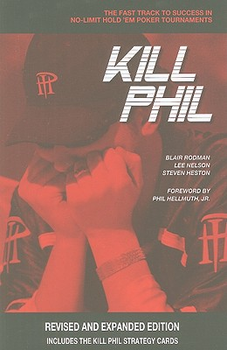
Final table 9 players
Chip leader +30 BB Hyper Loose / Chip leader -30 BB Super Loose / 2nd or 3rd stack Loose / 4th or 5th stack Tight 6th or 7th stack Super Tight / 8th or 9th stack Hyper Tight
Final table 8 players
Chip leader +30 BB Hyper Loose / Chip leader -30 BB Super Loose / 2nd or 3rd stack Loose / 4th or 5th stack Tight 6th or 7th stack Super Tight / 8th stack Hyper Tight
Final table 7 players
Chip leader +30 BB Hyper Loose / Chip leader -30 BB Super Loose / 2nd or 3rd stack Loose /4th or 5th stack Tight 6th or 7th stack Super Tight
Final table 6 players
Chip leader +30 BB Hyper Loose / Chip leader -30 BB Super Loose / 2nd or 3rd stack Loose / 4th or 5th stack Tight 6th stack Super Tight
Final table 5 players
Chip leader Hyper Loose / 2nd stack Super Loose /3rd stack Loose / 4th or 5th stack Tight
Final table 4 or 3 players
Chip leader Hyper Loose / 2nd stack Super Loose / 3rd or 4th stack Loose
Final table 2 players
Special code for this instance
end

